**-------------------MODULE 2-----------------**

**1. Make connection to different data source ( Excel Source )**

**2. Extract**

**3. Transform**

**4. Load to new target system - SQL Server**

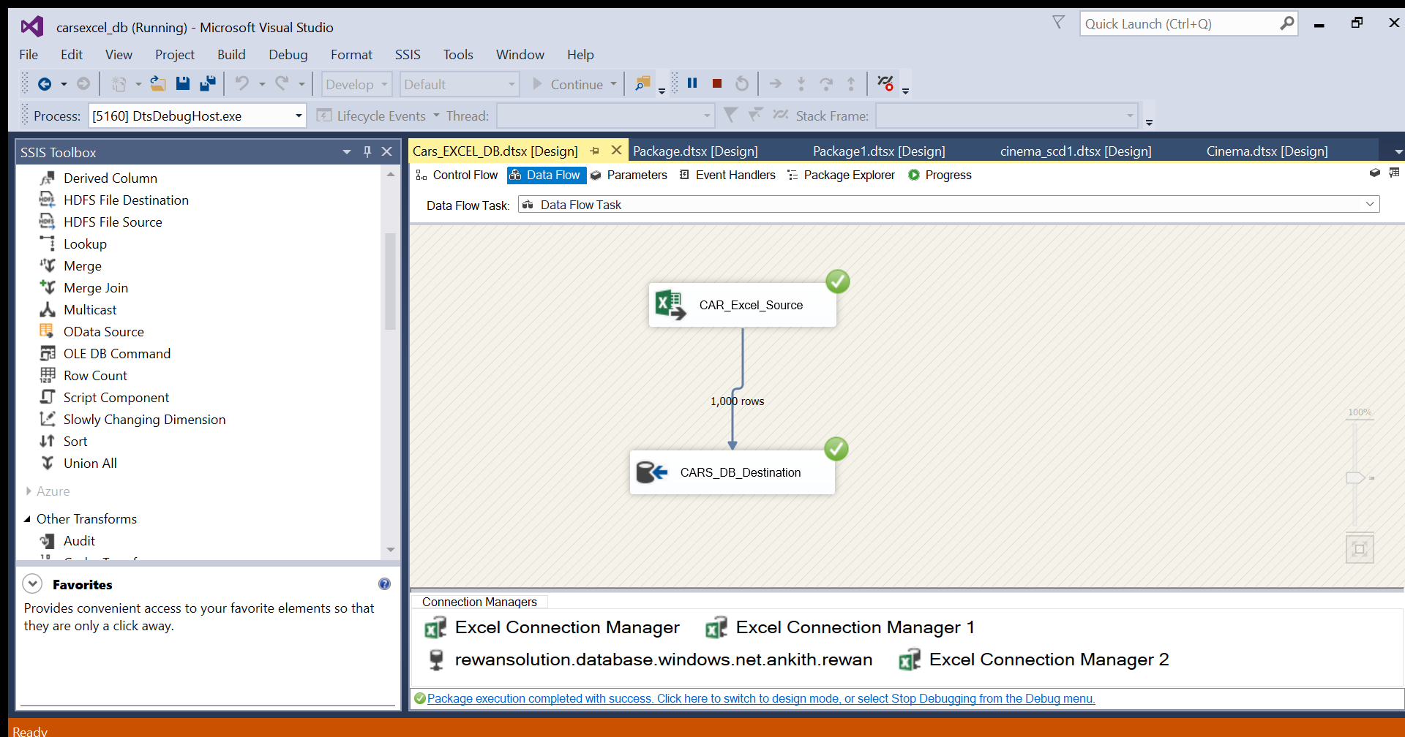

**---------SQL SERVER TABLE Cars--------**

**CREATE** **TABLE** Cars (

[SupplierID] **float**,

[SupplierAddress] **nvarchar**(255),

[SupplierName] **nvarchar**(255),

[SupplierContactDetails] **nvarchar**(255),

[ProductID] **float**,

[CarMaker] **nvarchar**(255),

[CarModel] **nvarchar**(255),

[CarColor] **nvarchar**(255),

[CarModelYear] **float**,

[CarPrice] **float**,

[CustomerID] **nvarchar**(255),

[CustomerName] **nvarchar**(255),

[Gender] **nvarchar**(255),

[JobTitle] **nvarchar**(255),

[PhoneNumber] **nvarchar**(255),

[EmailAddress] **nvarchar**(255),

[City] **nvarchar**(255),

[Country] **nvarchar**(255),

[CountryCode] **nvarchar**(255),

[State] **nvarchar**(255),

[CustomerAddress] **nvarchar**(255),

[OrderDate] **float**,

[OrderID] **nvarchar**(255),

[ShipDate] **float**,

[ShipMode] **nvarchar**(255),

[Shipping] **nvarchar**(255),

[PostalCode] **float**,

[Sales] **float**,

[Quantity] **float**,

[Discount] **float**,

[CreditCardType] **nvarchar**(255),

[CreditCard] **float**,

[CustomerFeedback] **nvarchar**(255)

)

---ddl,dml,dql on data source tables---

**Truncate** **table** cars

**

**5. Perform SCD 1 & SCD2 dimension table modelling**

**-----------From Excel source to OLE DB Destination----------**

**Excel Source**

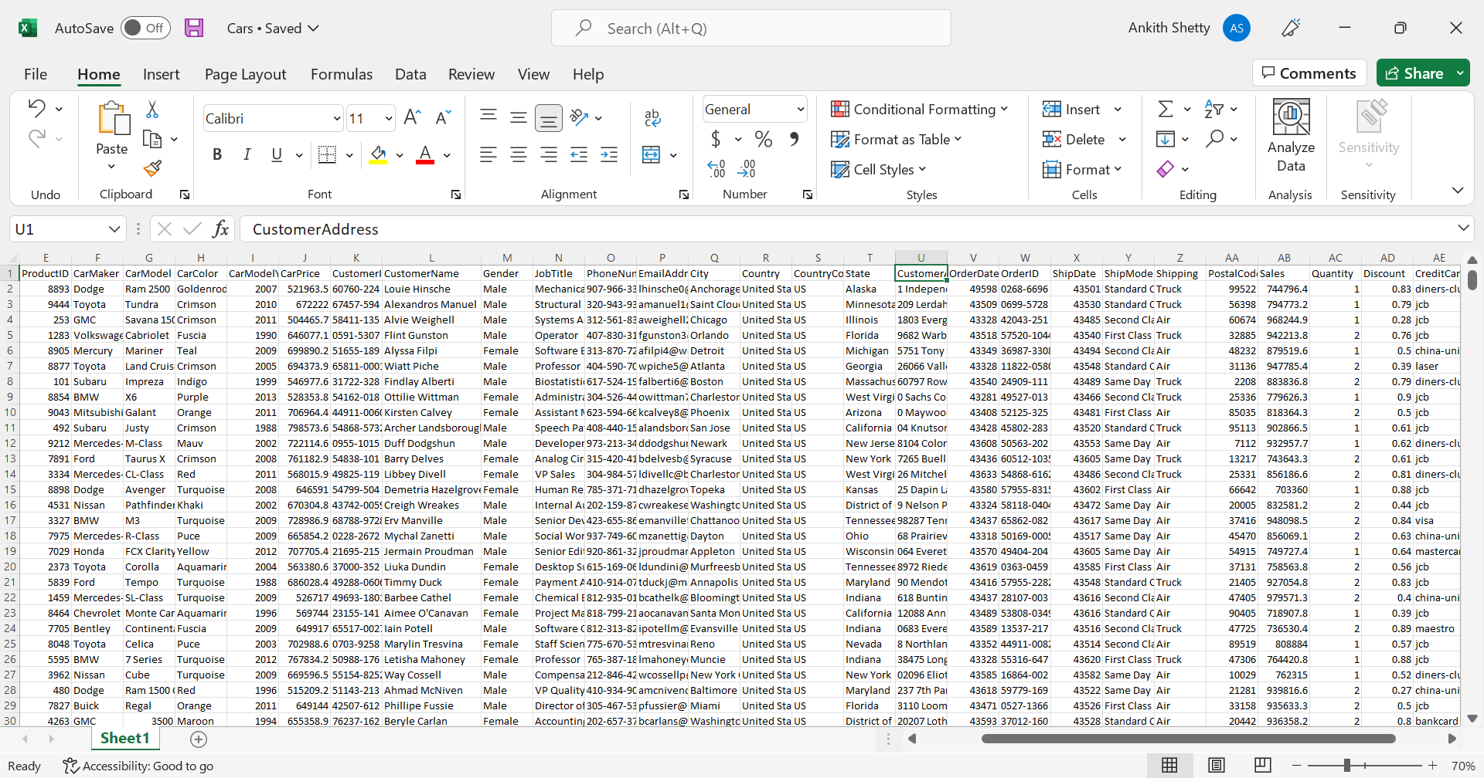

**---OLE DB Destination---**

**CREATE** **TABLE** Cars_SCD_Transformation (

[SupplierID] **float**,

[SupplierAddress] **nvarchar**(255),

[SupplierName] **nvarchar**(255),

[SupplierContactDetails] **nvarchar**(255),

[ProductID] **float**,

[CarMaker] **nvarchar**(255),

[CarModel] **nvarchar**(255),

[CarColor] **nvarchar**(255),

[CarModelYear] **float**,

[CarPrice] **float**,

[CustomerID] **nvarchar**(255),

[CustomerName] **nvarchar**(255),

[Gender] **nvarchar**(255),

[JobTitle] **nvarchar**(255),

[PhoneNumber] **nvarchar**(255),

[EmailAddress] **nvarchar**(255),

[City] **nvarchar**(255),

[Country] **nvarchar**(255),

[CountryCode] **nvarchar**(255),

[State] **nvarchar**(255),

[CustomerAddress] **nvarchar**(255),

[OrderDate] **float**,

[OrderID] **nvarchar**(255),

[ShipDate] **float**,

[ShipMode] **nvarchar**(255),

[Shipping] **nvarchar**(255),

[PostalCode] **float**,

[Sales] **float**,

[Quantity] **float**,

[Discount] **float**,

[CreditCardType] **nvarchar**(255),

[CreditCard] **float**,

[CustomerFeedback] **nvarchar**(255)

)

**

**----Here in slowly changing dimension columns we change customer feedback to changing attribute to get the updated values---**

**---Current Excel Source Customer Feedback(In Row 1)---**

**---Updated Customer feedback(In Row 1)---**

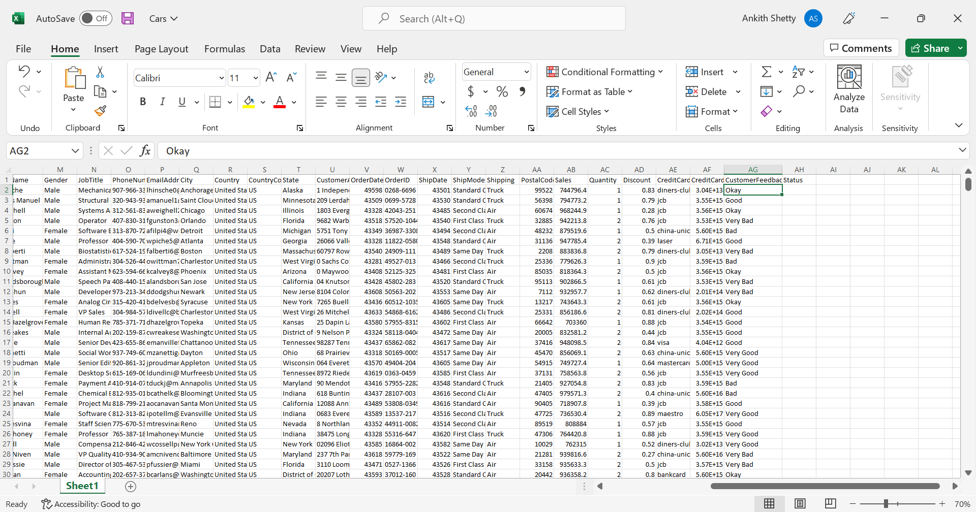

**-----Customer feedback changed from bad to okay in excel source----**

**---SCD1 Transformation---**

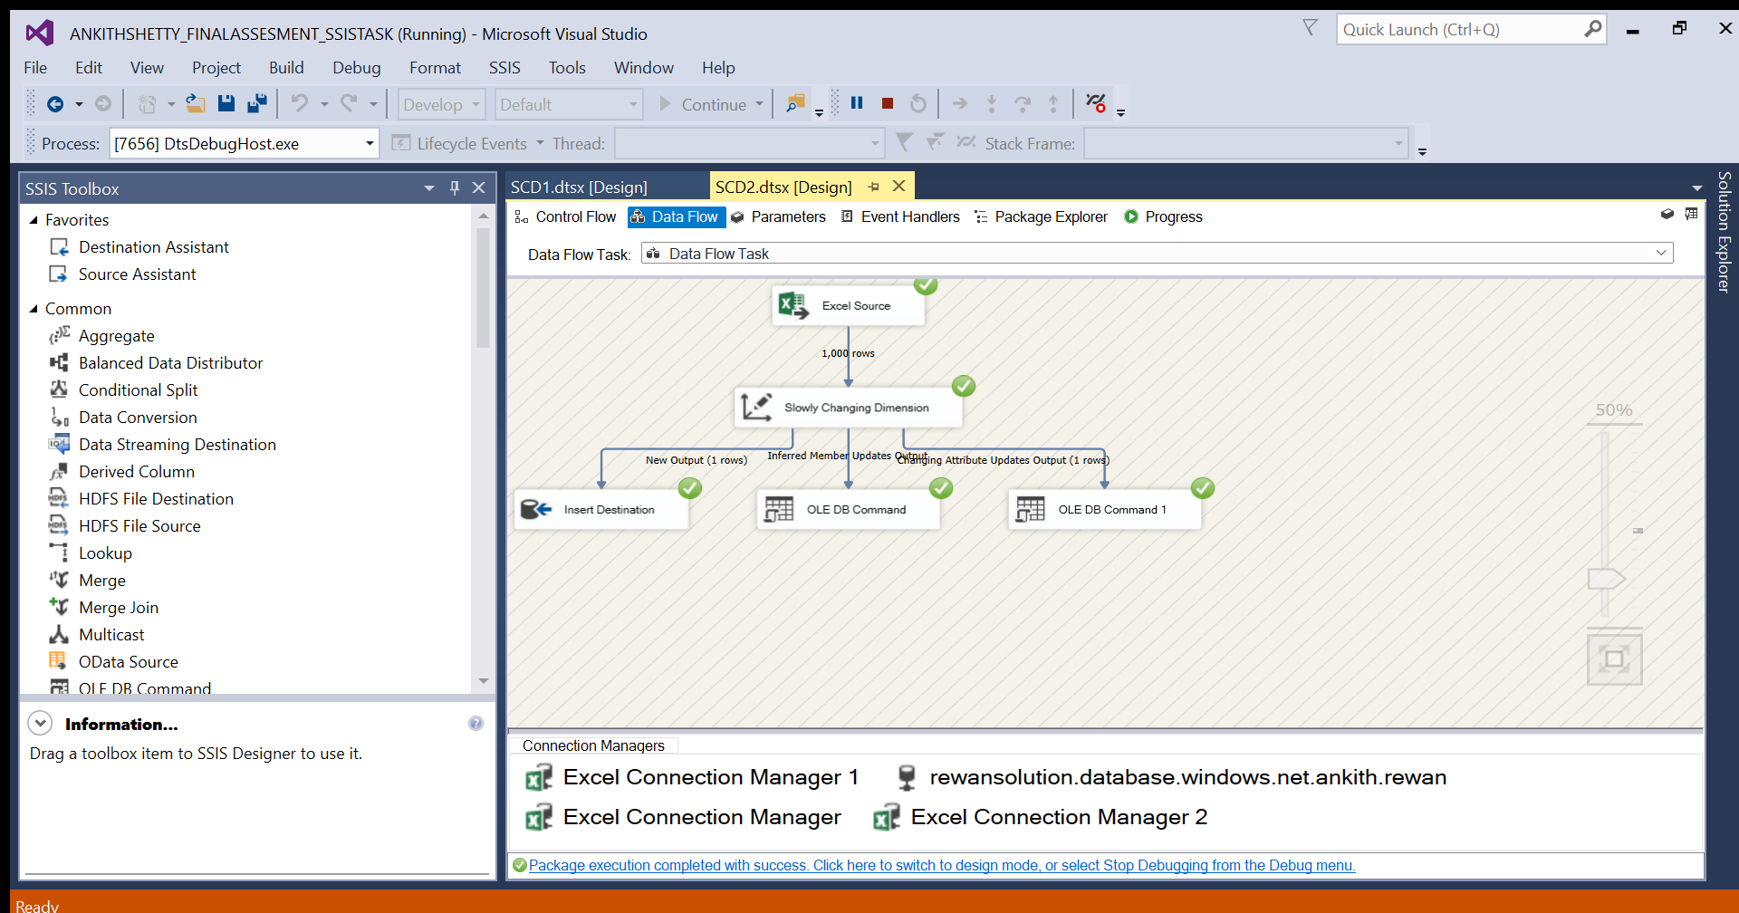

**---Cars_SCD_Transformation DB destination after SCD1 transformation output---**

**----Customer feedback value is updated in destination table---**

**---SCD2 Transformation---**

**---Current Excel source Values(Row 998 and Row 999)---**

**---Updated Excel Source values---**

**Here Order_date and order_Id is changed by keeping all other values same from row 998**

**---SCD2 Column Values---**

**Customer_name and Customer_feedback as historical attributes and order_date, order_id, ship_date and ship_mode as changing attributes.**

**---SCD2 Transformation SSIS---**

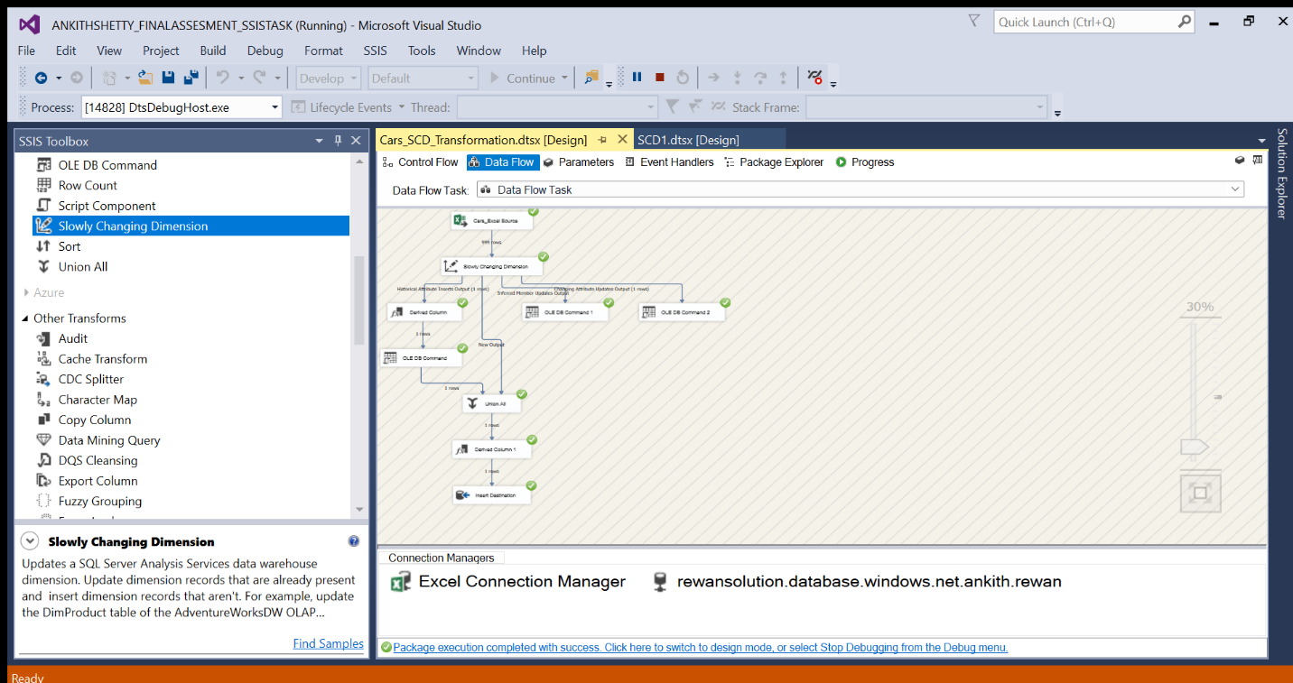

**---SCD2 Output---**

**select** * **from** Cars_SCD_Transformation

**Output shows current and expired values**

**---AGGREGATE Function---**

---Cars Aggregate table---

**CREATE** **TABLE** Cars_Aggregate(

[MAX_CarPrice] **float**

)

**---Aggregate transformation---**

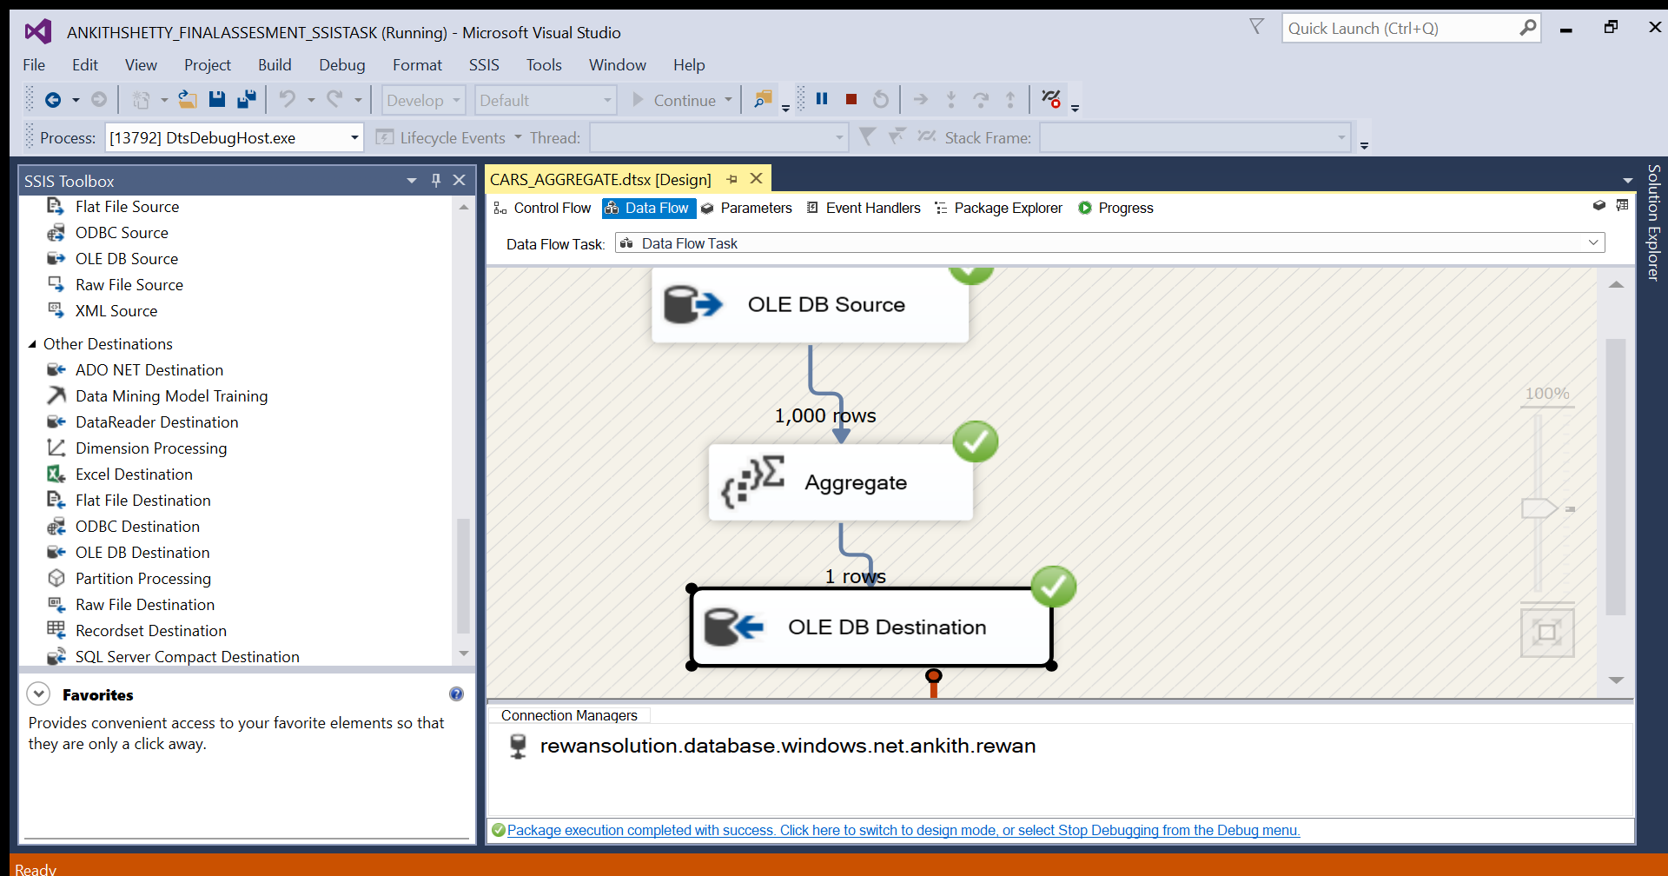

**---Cars_agrregate destination table output---**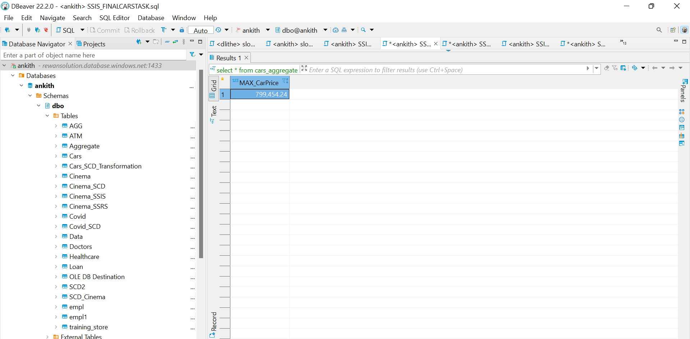

**---2nd Data Source---**

**---Covid Excel to DB conversion---**

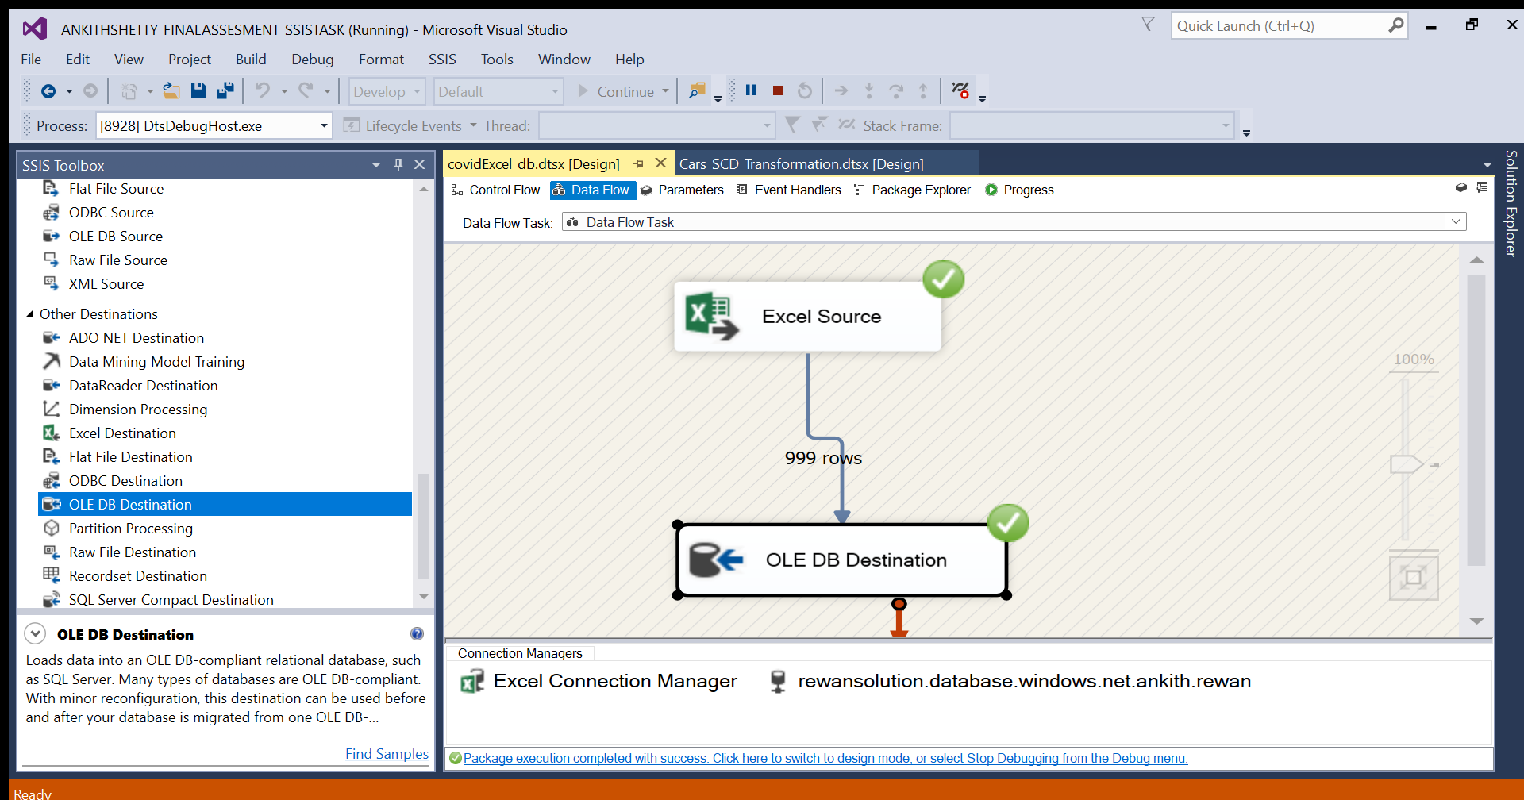

**---SQL DB destination---**

**CREATE** **TABLE** Covid(

[DRG ID] **float**,

[DRG Definition] **nvarchar**(255),

[Provider Id] **float**,

[Provider Name] **nvarchar**(255),

[Provider Street Address] **nvarchar**(255),

[Provider City] **nvarchar**(255),

[Provider State] **nvarchar**(255),

[Provider Zip Code] **float**,

[Hospital Referral Region (HRR) Description] **nvarchar**(255),

[Total Discharges] **float**,

[Average Covered Charges] **float**,

[Average Total Payments] **float**,

[Average Medicare Payments] **float**

)

---SCD Table---

**CREATE** **TABLE** Covid_SCD(

[DRG ID] **float**,

[DRG Definition] **nvarchar**(255),

[Provider Id] **float**,

[Provider Name] **nvarchar**(255),

[Provider Street Address] **nvarchar**(255),

[Provider City] **nvarchar**(255),

[Provider State] **nvarchar**(255),

[Provider Zip Code] **float**,

[Hospital Referral Region (HRR) Description] **nvarchar**(255),

[Total Discharges] **float**,

[Average Covered Charges] **float**,

[Average Total Payments] **float**,

[Average Medicare Payments] **float**

)

---SCD1 COLUMN Values---

**In slowly changing dimension column update provider Id as changing attribute to update value**

---update Source Covid value---

**update** Covid

**set** [Provider Id]=10002 **where** [Average Covered Charges]=32963.07692

---SCD1 Output---

Output shows updated provider Id value

**---SCD 2 Transformation---**

**---Create SCD2 Destination Table---**

**CREATE** **TABLE** Covid_SCD2 (

[DRG ID] **float**,

[DRG Definition] **nvarchar**(255),

[Provider Id] **float**,

[Provider Name] **nvarchar**(255),

[Provider Street Address] **nvarchar**(255),

[Provider City] **nvarchar**(255),

[Provider State] **nvarchar**(255),

[Provider Zip Code] **float**,

[Hospital Referral Region (HRR) Description] **nvarchar**(255),

[Total Discharges] **float**,

[Average Covered Charges] **float**,

[Average Total Payments] **float**,

[Average Medicare Payments] **float**,

[start_date] **datetime**,

[end_date] **datetime**,

[status] **varchar**(255)

)

**---Update Source Table value to get ---**

**update** Covid

**set** [Provider Name] ='Amit Rajput' **where** [Provider Street Address] ='Hampankatta,Mangalore'

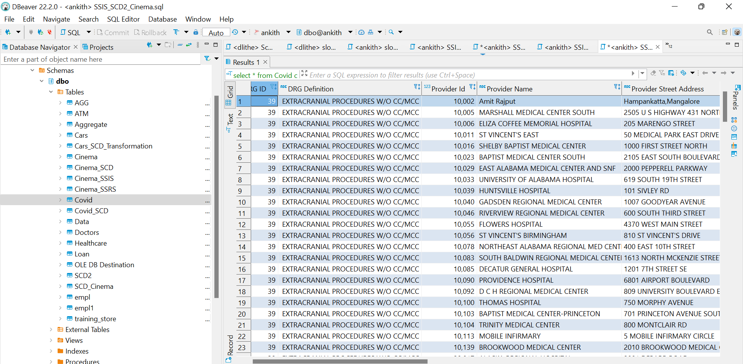

---SCD Transformation Values---

**In slowly changing dimension column update Provider Name as Historical attribute**

**In slowly changing dimension column update start_time and end_time with variable set to System::StartTime**

---SCD Transformation---

---SCD output---

---Update Source Table again to get End_date values---

**update** Covid

**set** [Provider Name] ='Ankith' **where** [Provider Id] =10005

---SCD Transformation---

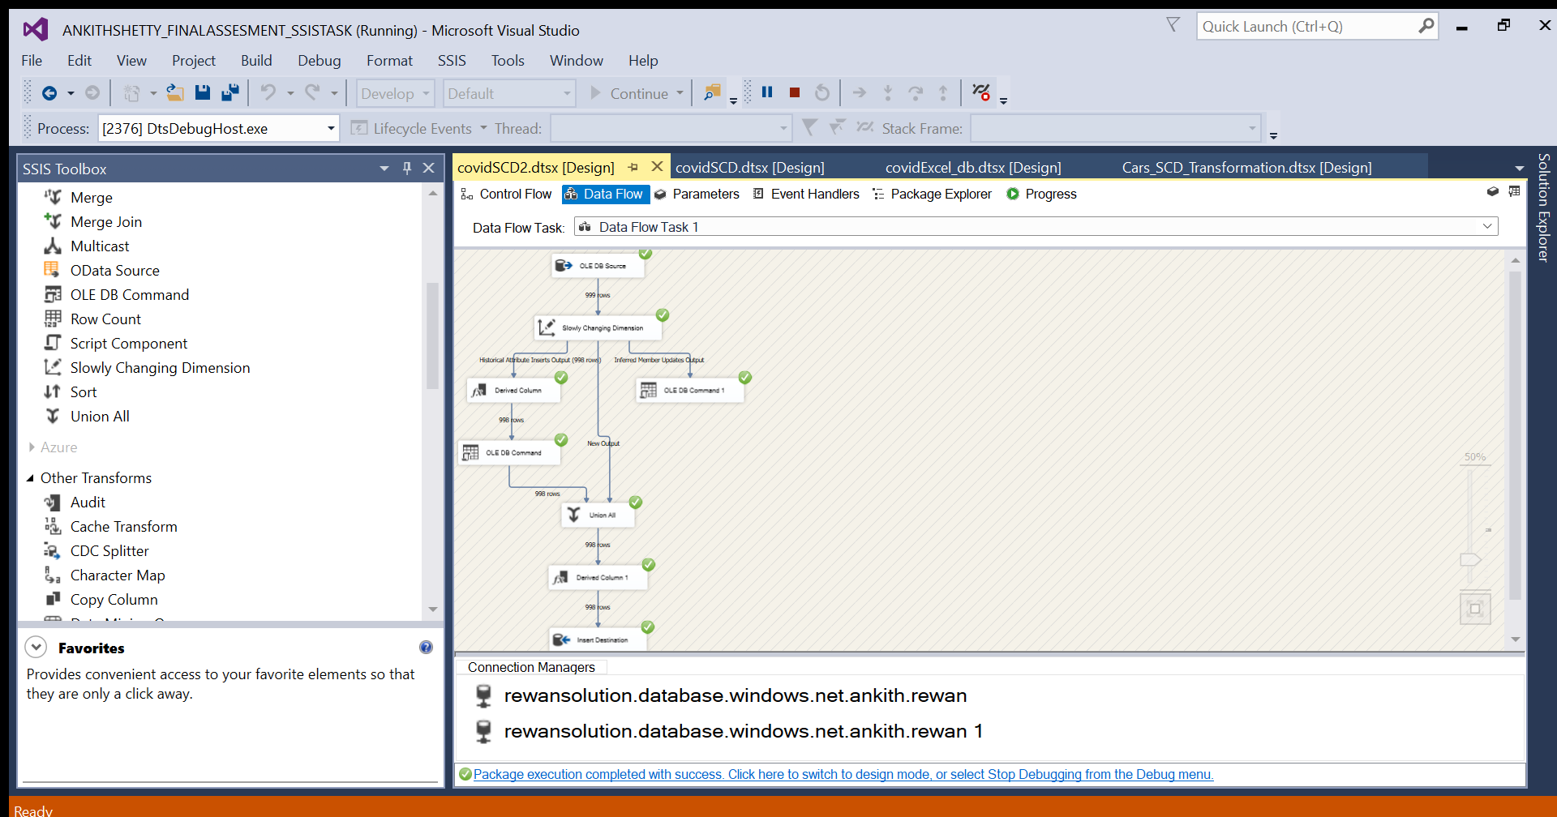

---SCD Output---

End_date value is updated in destination table

---Update to get status values by unselecting start_date,end_date and selecting status in SCD column values---

**update** Covid

**set** [Provider Name] ='Amit SIngh' **where** [Provider Id] =10002

**---SCD2 Transformation---**

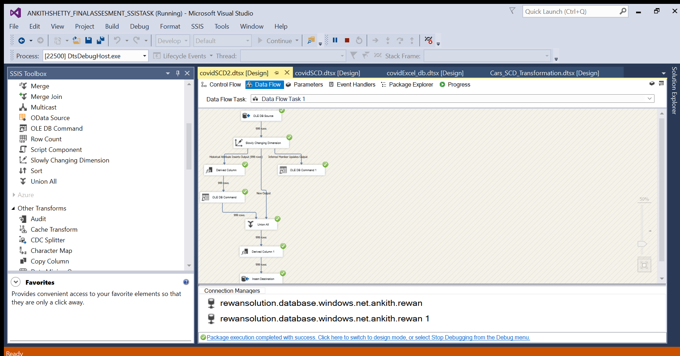

**---SCD2 Output---**

Status is updated in Destination table

**---Covid Aggregate Function---**

---create covid_aggregate table---

**CREATE** **TABLE** covid_aggregate (

[Sum_Total Discharges] **float**

)

---Covid aggregate Transformation---

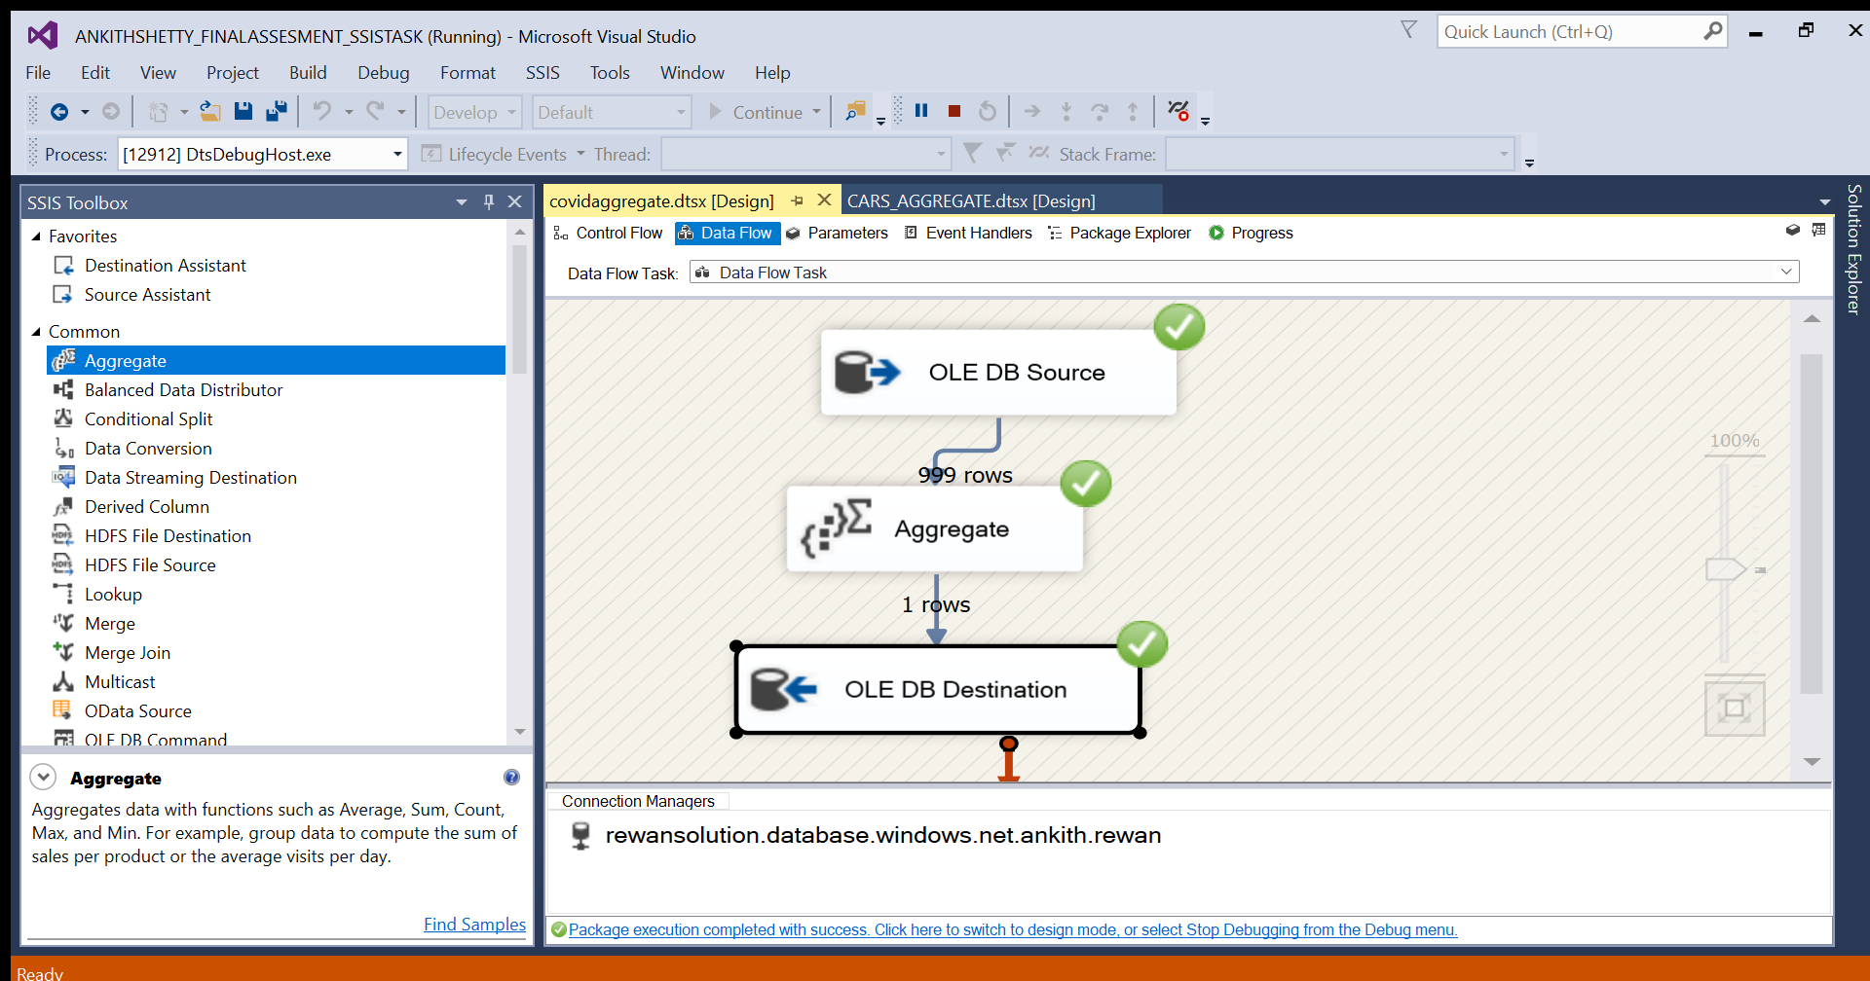

**---Covid_aggregate destination table output---**

